Introduction to Python

Markdown Headings:

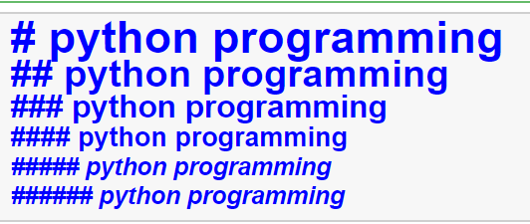

Ordered and Unordered list:

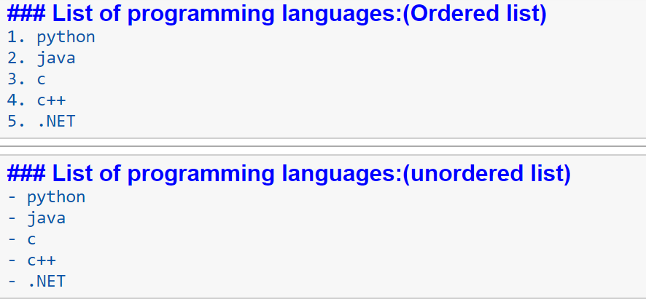

Bold and Italic:

**Python Programming**

*python Programming*

Linking URL:

[click here](<https://tinyurl.com/introduction-to-python>)

**Inserting an image:**

1. ![image](<https://cdn.pixabay.com/photo/2015/04/23/22/00/tree-736885__340.jpg>)
2. <img src="https://cdn.pixabay.com/photo/2015/04/23/22/00/tree-736885__340.jpg" width=200 height=200 >

C:

#include<stdio.h>

Void main()

{

printf(“Hello World!!”);

}

Save → .c

Compile

Run

Introduction to Python:

1. Different paradigms

2. Interpreted PL

3. open source

4. Object Oriented PL

Numeric Data types:

1. int

2. float

3. Complex

Example:

a = 10 #integer

b = 23.34 #float

c = 12+3j #Complex number

print(type(a),type(b),type(c))

Example:

c1 = 4+5j

c2 = complex(6,8)

print(c1+c2)

print(c2.real)#real part of the complex number

print(c2.imag)#imaginary part of the complex number

**input and output functions:**

#input --> input()

#output --> print()

a = int(input("Enter the value of a"))

b = int(input("Enter the value of b"))

#end-->new line

#sep -->space

print(a+b,end=" ")

print(a-b,a*b,a/b,sep=",")

#### **Operators:symbol which performs some specific task**

#### **Operands : values given to operator are known as operands**

**Arithmetic operators:**

+,-,*,/,%,//(floor division),**(exponent)

Example:

a = int(input("enter a value"))

b = int(input("enter b value"))

print(a + b)

print(a - b)

print(a * b)

print(a / b)#float quotient

print(a % b)#Remainder

print(a // b)#int quotient

print(a ** b)# 2 5

**Relational operators:**

<,>,<=,>=,==,!=

print(a < b)#True

print(a > b)

print(a <= b)

print(a >= b)

print(a == b)

print(a != b)

**Logical operators:**

and,or,not -->return type - Boolean

#print(help("keywords"))

print(a < b and a>1)

print(a < b or a>1)

print(not a < b)

**Membership operators :**

in,not in

list1 = [12,23,34,45,56,67]

print(12 in list1)#True

print(120 in list1)#False

print(12 not in list1)#False

print(120 not in list1)#True

**Conditional statements:**if,else,elif

if a < b:

print("a is less than b")

elif a > b:

print("a is greater than b")

else:

print("a or equals to b")

Question : Find the largest of three numbers

a = int(input("enter a value"))

b = int(input("enter b value"))

c = int(input("enter c value"))

if a>b and a>c:

print("largest number is a:",a)

elif b>c:

print("largest number is b:",b)

else:

print("largest number is c:",c)

Loops : while,for

# print 1 to n values

n = int(input("enter n value"))

i = 1

while i<=n:

print(i,end=" ")

i += 1#i=i+1

Output:

enter n value10

1 2 3 4 5 6 7 8 9 10